**Bernoulli Distribution**

Let’s start with the easiest distribution that is Bernoulli Distribution. It is actually easier to understand than it sounds!

All you cricket junkies out there! At the beginning of any cricket match, how do you decide who is going to bat or ball? A toss! It all depends on whether you win or lose the toss, right? Let’s say if the toss results in a head, you win. Else, you lose. There’s no midway.

A **Bernoulli distribution** **has only two possible outcomes, namely 1 (success) and 0 (failure), and a single trial.** So the random variable X which has a Bernoulli distribution can take value 1 with the probability of success, say p, and the value 0 with the probability of failure, say q or 1-p.

Sum of probabilities of these two events is 1, as p + 1 –p.

Here, the occurrence of a head denotes success, and the occurrence of a tail denotes failure.  
Probability of getting a head = 0.5 = Probability of getting a tail since there are only two possible outcomes.

The probability mass function is given by: px(1-p)1-x  where x € (0, 1).  
It can also be written as

https://s3-ap-south-1.amazonaws.com/av-blog-media/wp-content/uploads/2017/09/16150804/image57.png

The probabilities of success and failure need not be equally likely, like the result of a fight between me and Undertaker. He is pretty much certain to win. So in this case probability of my success is 0.15 while my failure is 0.85

Here, the probability of success(p) is not same as the probability of failure. So, the chart below shows the Bernoulli Distribution of our fight.

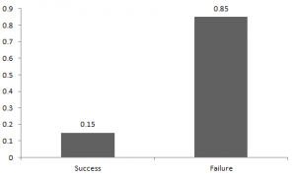

Here, the probability of success = 0.15 and probability of failure = 0.85. The expected value is exactly what it sounds. If I punch you, I may expect you to punch me back. Basically expected value of any distribution is the mean of the distribution. The expected value of a random variable X from a Bernoulli distribution is found as follows:

E(X) = 1*p + 0*(1-p) = p

The variance of a random variable from a bernoulli distribution is:

V(X) = E(X²) – [E(X)]² = p – p² = p(1-p)

There are many examples of Bernoulli distribution such as whether it’s going to rain tomorrow or not where rain denotes success and no rain denotes failure and Winning (success) or losing (failure) the game.

**Binomial Distribution**

Let’s get back to cricket.  Suppose that you won the toss today and this indicates a successful event. You toss again but you lost this time. If you win a toss today, this does not necessitate that you will win the toss tomorrow. Let’s assign a random variable, say X, to the number of times you won the toss. What can be the possible value of X? It can be any number depending on the number of times you tossed a coin.

There are only two possible outcomes. Head denoting success and tail denoting failure. Therefore, probability of getting a head = 0.5 and the probability of failure can be easily computed as: q = 1- p = 0.5.

**A distribution where only two outcomes are possible, such as success or failure, gain or loss, win or lose and where the probability of success and failure is same for all the trials is called a Binomial Distribution.**

The outcomes need not be equally likely. Remember the example of a fight between me and Undertaker? So, if the probability of success in an experiment is 0.2 then the probability of failure can be easily computed as q = 1 – 0.2 = 0.8.

Each trial is independent since the outcome of the previous toss doesn’t determine or affect the outcome of the current toss. **An experiment with only two possible outcomes repeated n number of times is called binomial.** The parameters of a binomial distribution are n and p where n is the total number of trials and p is the probability of success in each trial.

On the basis of the above explanation, the properties of a Binomial Distribution are

1. Each trial is independent.
2. There are only two possible outcomes in a trial- either a success or a failure.
3. A total number of n identical trials are conducted.
4. The probability of success and failure is same for all trials. (Trials are identical.)

The mathematical representation of binomial distribution is given by:

https://s3-ap-south-1.amazonaws.com/av-blog-media/wp-content/uploads/2017/09/17154326/image65.png

A binomial distribution graph where the probability of success does not equal the probability of failure looks like

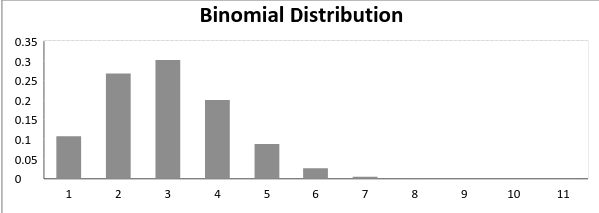

Now, when probability of success = probability of failure, in such a situation the graph of binomial distribution looks like

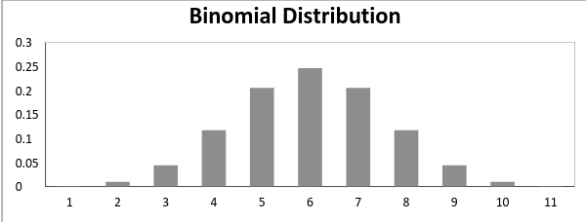

The mean and variance of a binomial distribution are given by:

Mean -> µ = n*p

Variance -> Var(X) = n*p*q

For any distribution refer this website.

<https://www.analyticsvidhya.com/blog/2017/09/6-probability-distributions-data-science/>